Moteur Vapeur
  - ME421 Steam Engine Project
  - Final Design Summary
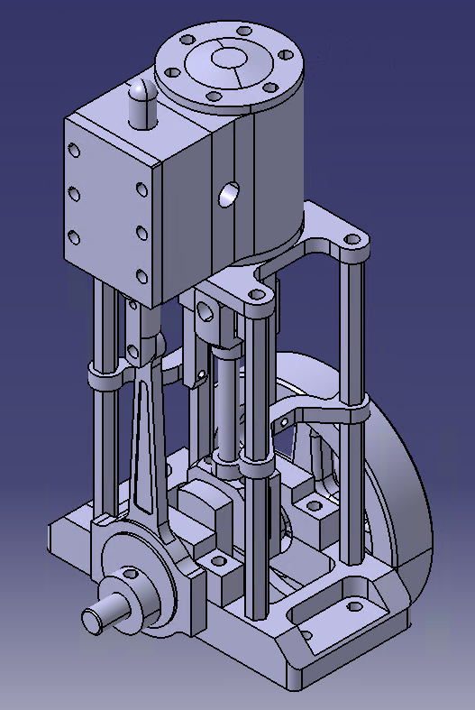
  - Team Members
  - Dwain Stucker, Kaitlin Coad

Project notes
This project was not too difficult. Most of the parts fit together without issue and there was only one instance where a part had to be modified to work properly. Assumptions had to be made in a few places but as long as the assumed dimensions are consistent across parts, they do not affect the function of the final product.
There are multiple standardized parts (mainly bolts and fasteners) whose drawings were not included in the package, but they are not needed to model a functional assembly. There were three parts that were not defined but are crucial for assembling the design:
- Part 13C02 is needed to connect the crankshaft to the piston assembly.
- Part C16 is needed to connect the upper assembly base to the lower assembly base.
- Part C03 is needed to connect the steam guide to the camshaft.
All the parts in the package can easily be separated into two major subassemblies and one minor subassembly. We would recommend dividing this between 2-3 students. The project requires too much work for one person to handle alone but is not complex enough to justify a team of 4.

Part: | #: | Pg # | Difficulty (1-5) DS/KC | Date Completed | Author | Part Description | Notes
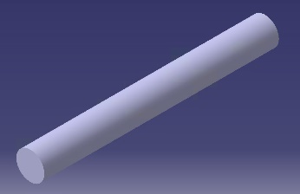 | 23 | 2 | 1/1 | 14-Apr | DS | Small Piston Rod
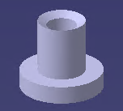 | 22 | 2 | 1/1 | 14-Apr | DS | Grommet
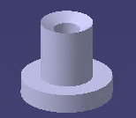 | 21 | 2 | 1/1 | 14-Apr | DS | Grommet
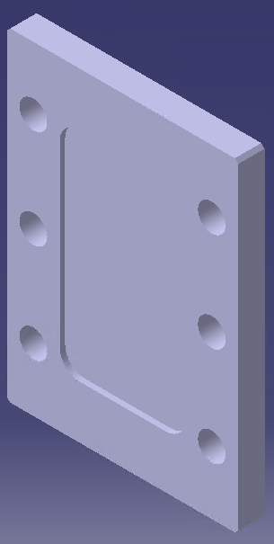 | 20 | 2 | 2/2 | 14-Apr | DS | Steam Box Cover | Didn’t include embossed logo since it was not defined
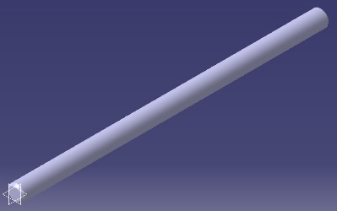 | 19 | 3 | 1/1 | 20-Apr | KC | Piston Rod | I think one end should be threaded but the size is not specified
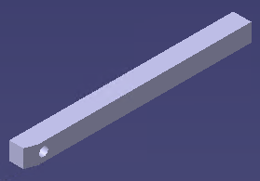 | 18 | 3 | 1/1 | 14-Apr | DS | Guild Rod | The 5mm square profile of this part doesn't fit in the engine, it must be a circular rod of at max (4mm d)

Part: | #: | Pg # | Difficulty (1-5) DS/KC | Date Completed | Author | Part Description | Notes
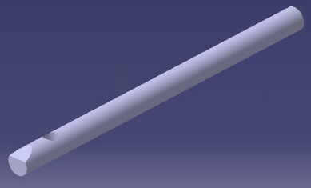 | 18C09 | - | 1/1 | 7-May | DS | Guild Rod | Custom modified version of part 18 to make design work
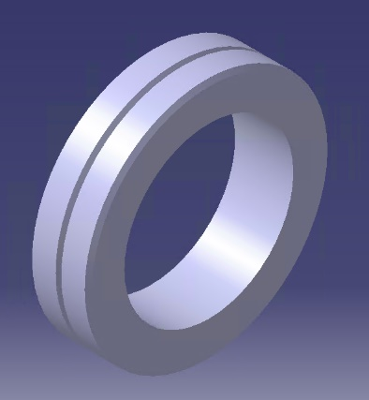 | 17 | 4 | 1/2.5 | 26-Apr | KC | Piston Seal | There is a "coupe 0 2" notation on the drawing but the meaning is unclear. This part is not complex, but interpreting the drawing took some effort.
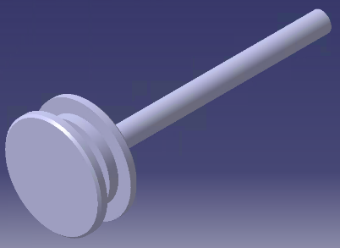 | 16 | 4 | 2/3 | 26-Apr | KC | Piston
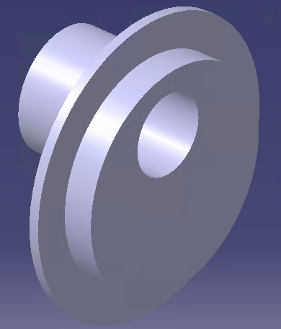 | 15b | 5 | 2/3 | 14-Apr | DS | Piston Cam | Had to set length of upper valve extrusion (7mm)
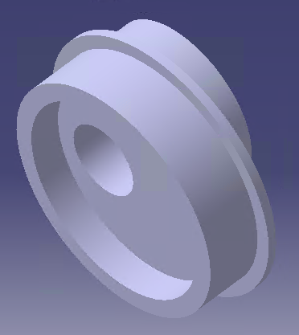 | 15a | 5 | 2/3 | 14-Apr | DS | Piston Cam | Part 15 had to be made in two parts
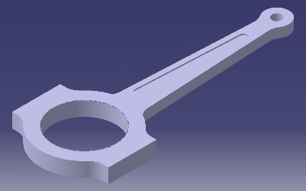 | 14 | 5 | 2/2 | 20-Apr | KC | Cam Rod

Part: | #: | Pg # | Difficulty (1-5) DS/KC | Date Completed | Author | Part Description | Notes
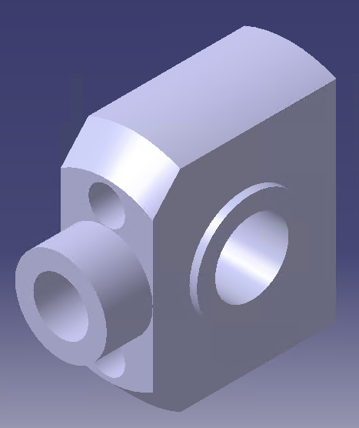 | 13 | 6 | 3/3 | 16-Apr | DS | Crankshaft Connector | Kinda confusing but everything is defined.
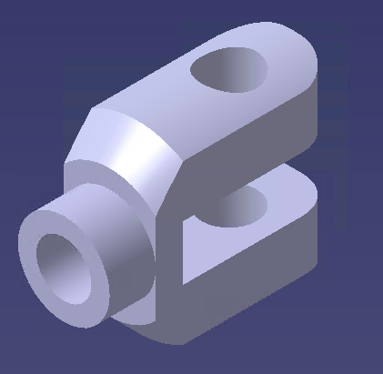 | 13C02 | - | 3/3 | 7-May | DS | Crankshaft Connector | Custom version of part 13 designed to connect piston to crankshaft
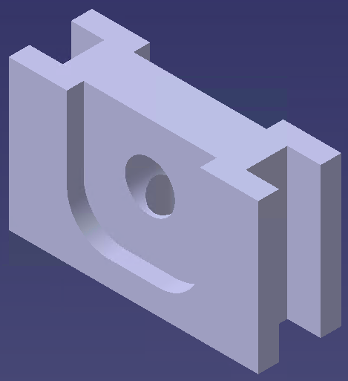 | 12 | 6 | 2/2 | 14-Apr | DS | Connector rod linkage | Fillet wasn't defined, set to (5mm r)
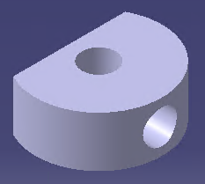 | 11 | 7 | 1/1.5 | 14-Apr | DS | Shaft Spacer/collar
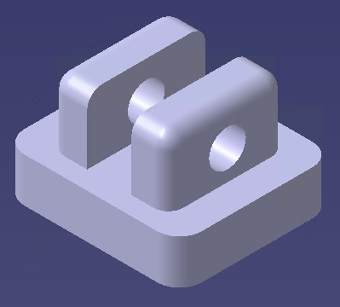 | 10 | 7 | 2/2 | 28-Apr | KC | Steam guide | Assumed a fillet radius of 2mm on top boss for consistency with other fillets on same part

Part: | #: | Pg # | Difficulty (1-5) DS/KC | Date Completed | Author | Part Description | Notes
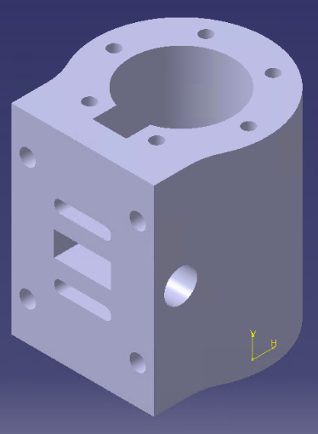 | 9 | 8 | 4/4 | 19-Apr | DS | Steam Box | Defining the intake protrusion by using a diameter of (52mm) is an odd way of doing it.  The bottom bolt holes don't line up with the bolt holes in part 2
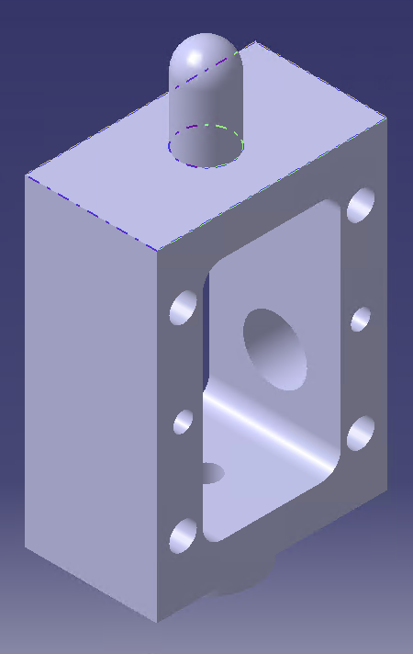 | 8 | 9 | 4/4 | 28-Apr | KC | Steam Box | Found specifications for "1/8 gaz" here: https://fr.wikipedia.org/wiki/Filetage_gaz
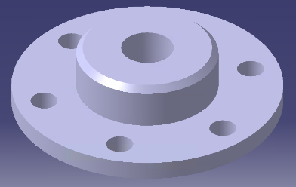 | 7 | 10 | 3/3 | 26-Apr | KC | Piston Cylinder Cover (Base) | Length of 1/8" twist pocket not specified, should be consistent with dimensions from Part 22
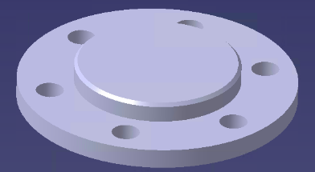 | 6 | 10 | 2/2 | 15-Apr | DS | Piston Cylinder Cover (Top)
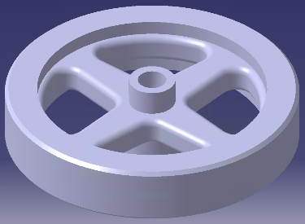 | 5 | 11 | 3/3 | 17-Apr | DS | Fly Wheel | The filleted outer corners of the 4 holes cut in the fly wheel were left undefined. They were set to a radius of (4mm) to match the inner defined corner.

Part: | #: | Pg # | Difficulty (1-5) DS/KC | Date Completed | Author | Part Description | Notes
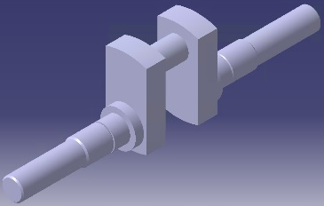 | 4 | 12 | 3/3 | 22-Apr | KC | Crank Shaft | Pad lengths for long face and outside adjacent shaft not specified but they total to 10mm. Pad lengths for outermost shaft and inside adjacent shaft not specified but they total to 33.4 mm.
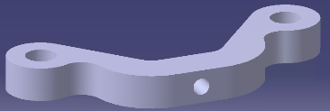 | 3 | 13 | 2/2 | 21-Apr | KC | Piston Assembly Base Plate
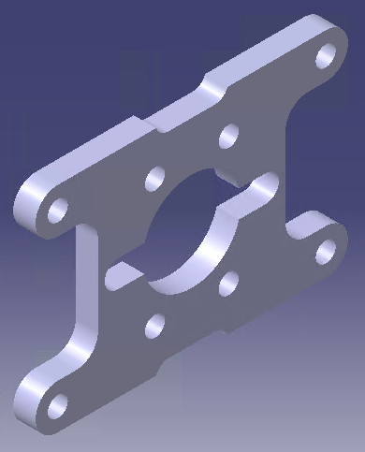 | 2 | 13 | 1/2 | 28-Apr | KC | Piston Assembly Base
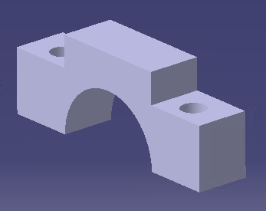 | 1a | 14 | 4/4 | 24-Apr | DS | Crankshaft Base | The axle clasp doesn’t define the resting bolt plane, set it to 2/3 of the part height (5.33mm)
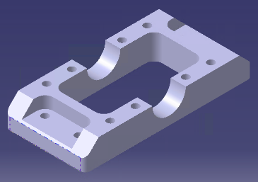 | 1b | 14 | 4/4 | 24-Apr | DS | Crankshaft Base | Took a while to sort out but everything was defined
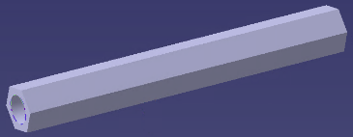 | C16 | - | 1/1 | 7-May | DS | Support Rod | Custom 50mm long hexagonal rod (face width of 3.5mm) with a hole passing through the center of diam. 4.2mm. Needed to support upper assembly.
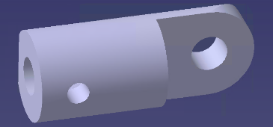 | C03 | - | 2/2 | 7-May | DS | Crankshaft Connector | Custom linkage to connect Piston Cam to Steam Guide

Profile Pictures
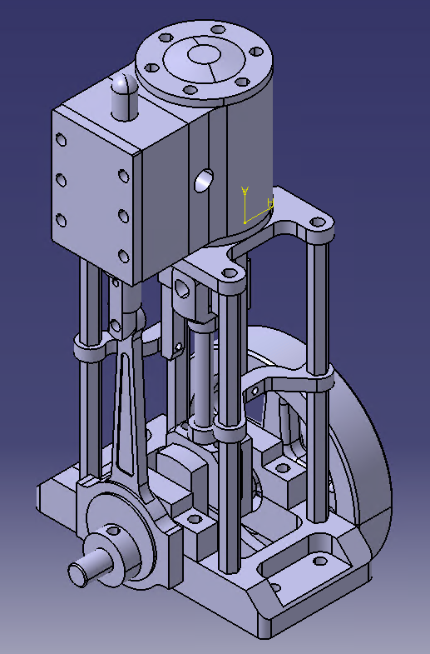
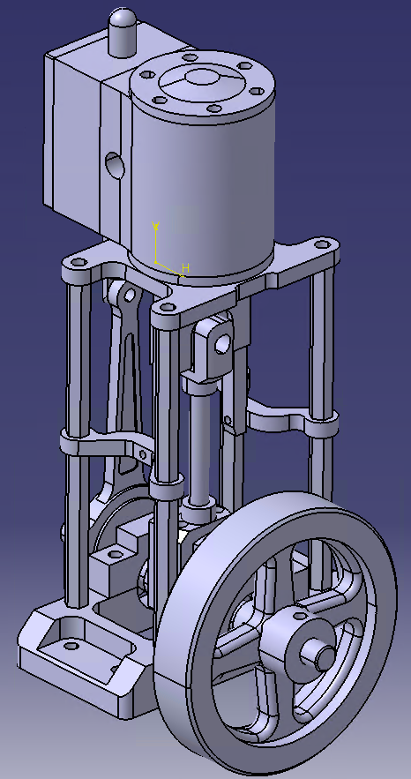
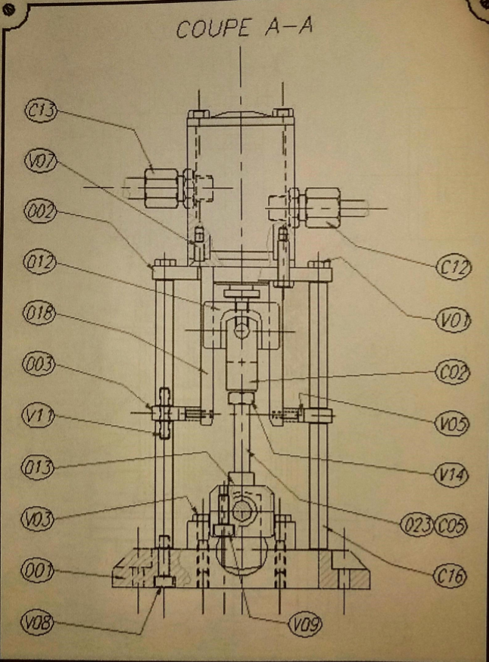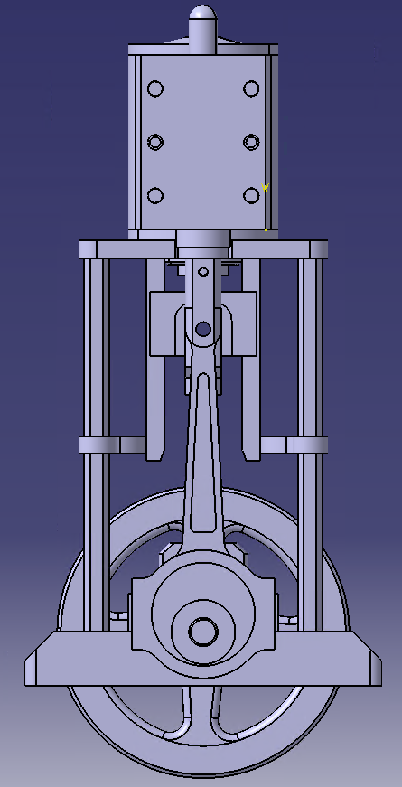
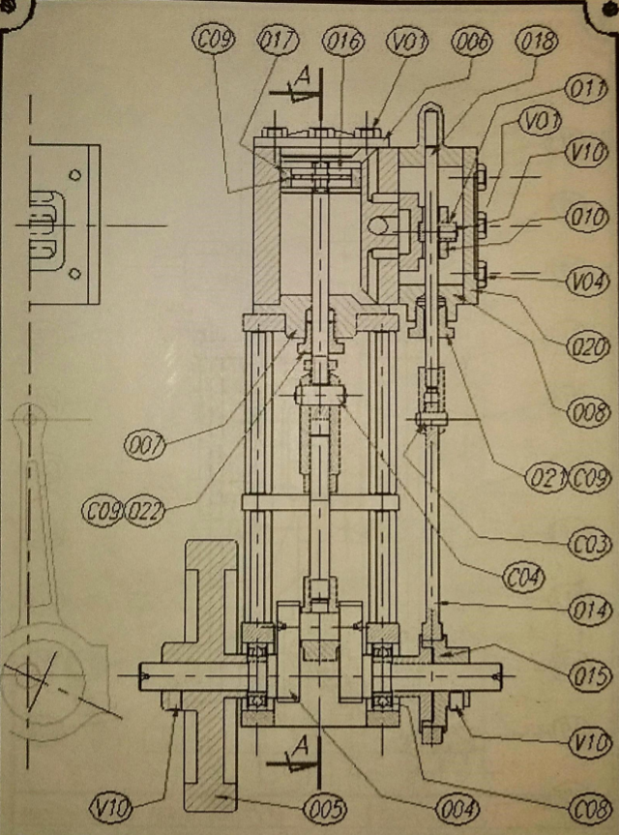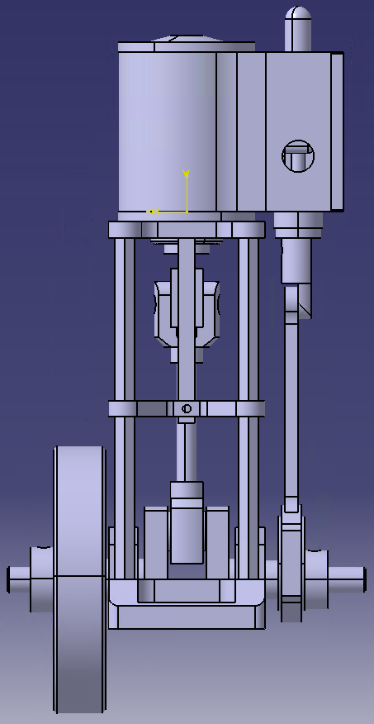

Custom Part Drawings

